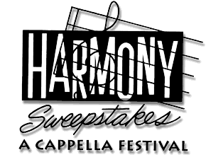

"In Celebration of the Human Voice - The Essential Musical Instrument"

FOR IMMEDIATE RELEASE | CONTACT JOHN NEAL: | john@singers.com 415-459-3955

Attention: CALENDAR EDITORS

HARMONY SWEEPSTAKES A CAPPELLA FESTIVAL NATIONAL FINALS TO BE HELD MAY 5TH AT MARIN VETERANS' AUDITORIUM IN SAN RAFAEL CALIFORNIA.

The Harmony Sweepstakes A Cappella Festival National Finals has been hailed as the "Superbowl of A Cappella" and for over two decades has served as the premiere American showcase for unaccompanied vocal harmony music.

Regional Champions from eight major U.S. cities are flown to the Bay Area to compete in these National Finals. Hosted by 2006 National Champions Hi-Fidelity (Los Angeles).

Competitors are Solstice (Bay Area), Men in Black (Boston), Nightwatch (Chicago), Face (Denver), Moira Smiley and VOCO (Los Angeles), DoubleShot! (Mid Atlantic/DC), The Fault Line (New York) and V-Chords (Pacific NW).

23RD ANNUAL HARMONY SWEEPSTAKES A CAPPELLA FESTIVAL NATIONAL FINALS

Marin Veterans' Memorial Auditorium
Avenue of the Flags, Marin Center, San Rafael

Saturday, May 5th 2007 - 8 PM

Tickets: $29.50 - $32.50

Tickets from the Marin Center Box Office: 415-499-6800
Buy Tickets online: www.ticketmaster.com

Further information at website: www.harmony-sweepstakes.com

The Harmony Sweepstakes A Cappella Festival is produced in association with the non-profit A Cappella Foundation, dedicated to the promotion of a cappella singing worldwide. Sponsors include the Primarily A Cappella catalog and website, www.singers.com, Primarily A Cappella Records and leading CD manufacturer Discmakers.
###

P O Box D, San Anselmo CA, 94979 | (415) 455-8602 Fax: (415) 459-1622

